

**DPSCDSB SKILLS ONTARIO MARCH 8th, 2023**

**WEB DESIGN & DEVELOPMENT**

**THEME:**  **“We are Many We are One”** STUDENT NAME: ________________________

**USB/XAMPP, CONTENT & IMAGES**: will be provided SCHOOL NAME: _________________________

You will be asked to create a web page or web pages pending your design, include a database and follow the scope below.

|  |  |
| --- | --- |
| **EVALUATION CRITERIA** | **WEIGHTING AND JUDGES COMMENTS** |
| **Content:**   * The purpose of the web site is clearly identified. Titles, logos, headings, communicate site intents and objectives. * Site content is organized in a logical and useful manner; it moves from introductory or general content to specific or detailed content. * Site content supports the intention of the site. The information is useful and creative. * The content is presented in an interesting and original manner. * Text and graphics are organized in a way to promote readability. * White space and other devices make the page easy to read or view. * Graphics and text work together to realize the objectives of the site. Graphics are not used for their own sake. * Page format is appropriate. Pages are not inordinately long. Scrolling is kept to an acceptable level. * Content of the site must be only material that the contestants create during the contest or is provided to them by the contest organizers. | 9% |
| **Navigation:**   * + Links are easily identifiable and their use is intuitive. Users can move easily both forward and backward through the site.   + The path to desired information is clear. Use of menus, image maps, input types, directs visitors to relative information.   + Site interactivity is good. Links, buttons, check boxes and text boxes are used to give the user a high level of engagement * Links to external web sites are meaningful, where applicable. * Links to information located on the same page (anchors) are appropriate. | 9% |
| **Visual:**   * The site is aesthetically appealing. Use of background and foreground colour promotes readability. * Graphic size, positioning and type enhance text and navigability. * Site visual theme is consistent. There are no jarring changes in layout, font usage, colour, as the visitor moves from page to page. * Visual design is creative. The visual design has a high level of originality. * The site includes original vector or bitmap graphics created by the competitor. * The site includes photographs and images (conversion to GIF or JPEG may be required) | 9% |
| **Site Structure:**   * Web pages must validate as either HTML or XHTML. * Web site must be consistent across all Web browsers. * Design a site that allows for easy updates and maintenance. | 4% |
| **Cascading Style Sheets:**   * Clearly separate content from presentation through the use of Cascading Style Sheets. * ID and class names are properly written and referenced using camel case notation. i.e. camelCase or CamelCase   not Camel Case where there is a space after the l and before the C. | 9% |
| **Web Form:**   * Demonstrate proficiency in the design of Web forms and the validation (client- or server-side) of form data. * Ensure that Web forms are properly marked up and accessible. | 9% |
| **Client-side Frameworks:**  Use of   * Bootstrap   AND/OR   * jQuery in a meaningful and useful manner in the development of the competition project. | 10% |
| **MySQL:**   * Create a database and tables from a description using MySQL and phpMyAdmin. * Write PHP code to create, read, update, and delete data entries to a MySQL database. | 10% |
| **~~Resume: Skills Ontario Competition only~~**   * ~~Resume is in a professional format.~~ | ~~5%~~ |
| **Theory:**   * Quiz – 10 questions HTML/CSS/BOOTSTRAP/DB | 10% |
| As the rules state, there are no ties. In the event of a tie, should competitors be tied in total points, the judge will inspect the HTML, CSS, JavaScript, JQUERY/BOOTSTRAP and PHP code in detail. The individual with the best-written code will break the tie. | |

**WHAT CAN YOU USE:**

**Based on the Skills Ontario Scope**

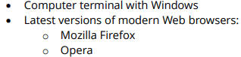



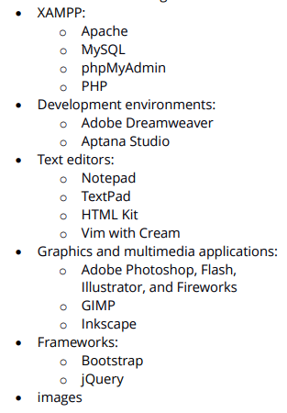

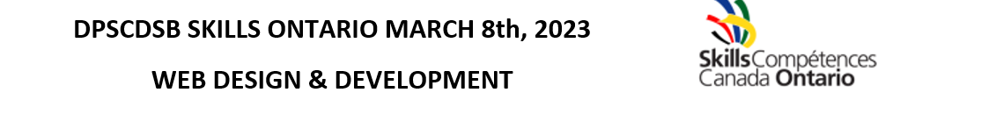INTRODUCTORY CONTENT:

Design and develop a web page that incorportates the them of Catholic Education Week and a student friendly website. Use the requirements listed above in the judging evaluation. Use bootstrap 5 and XAMPP for your database. One the attached USB you will have 3 images and content. Please layout the content and use a navigation bar. The requirements include you must have a HOME and REGISTER tab and 2 more tabs in the navigation bar.

CONTENT:

The Catholic Education Week biblical quote is, *“We, who are many, are one body in Christ, and individually we are members, one of another.”* (Romans 12:5)

Each year, the Catholic community of Ontario engages in a week-long celebration of the unique identity and distinctive contributions of Catholic education during Catholic Education Week. This year’s celebration is entitled, “Catholic Education: *We are Many, We are One*” and will be celebrated during the week of April 30-May 5. The theme for Catholic Education Week 2023 was inspired by the following considerations:

THEME FOR CATHOLIC EDUCATION WEEK

The theme for Catholic Education Week 2023 was inspired by the following considerations:

The Church worldwide has embarked on a synodal process, “a synod on synodality,” which centres on intentional listening: listening to each other and listening to the Holy Spirit. We have each been asked to actively reach out and listen to the voices and experiences of people where they are at and consider what steps the Holy Spirit is inviting us to take as we walk together. As the Catholic Bishops of Ontario highlighted in *Renewing the Promise*, “It is about taking the time to walk alongside one another, to listen and to teach, and in doing so, to transform.”

Ongoing recognition of the Truth & Reconciliation Commission and the importance of Indigenous culture and spirituality as we move forward together.

The Ministry of Education’s focus on Inclusion and Equity resonates with all educators and administrators as we desire to serve all of God’s children and Pope Francis’ encyclical entitled, *Fratelli Tutti*, will guide us in this good work.

The challenges to personal and spiritual well-being posed by the uncertainty of the current global crisis makes the timing and the concerns of Mental Health Week, which takes place during the same week as Catholic Education Week, all the more relevant.

There are five sub-themes, one for each day of Catholic Education Week. The five sub-themes for Catholic Education Week illuminate the path to being many and one. We achieve this unity…

Monday: **When we see / En voyant**

Tuesday: **When we listen / En écoutant**

Wednesday: **When we reflect / En réfléchissant**

Thursday: **When we learn / En apprenant**

Friday: **When we act /**  **En agissant**

**WE ARE MANY WE ARE ONE IN CLIMATE CHANGE**

While global leaders are in the COP26 meetings talking about how to tackle climate change, more and more activists are being threatened and killed for protecting the forests, waters, and biodiversity that our people and our planet are most in need of. The most vulnerable members of our human family are bearing the largest burden, dealing with the worst impacts of climate change and facing negative effects of ill-planned, top-down climate “solutions”.

We know the choices we are making today will shape our communities, our economy, our health and the health of our planet for years to come, so let’s make sure our transition is towards a just economy that addresses integral human development. Human rights need to be respected and environmental harm avoided as we improve our global and national climate policies. We must make sure that people and the planet are at the centre of our just recovery.

**SCRIPTURE: James 1:19**

A reading from the letter of James.

Every generous act of giving, with every perfect gift, is from above, coming down from the Father of lights, with whom there is no variation or shadow due to change. In fulfillment of his own purpose he gave us birth by the word of truth, so that we would become a kind of first fruits of his creatures.

You must understand this, my beloved: let everyone be quick to listen, slow to speak, slow to anger.

The word of the Lord. **Thanks be to God.**

**A reading from the Encyclical Fratelli Tutti by Pope Francis**

48. The ability to sit down and listen to others, typical of interpersonal encounters, is paradigmatic of the welcoming attitude shown by those who transcend narcissism and accept others, caring for them and welcoming them into their lives. Yet “today’s world is largely a deaf world… At times, the frantic pace of the modern world prevents us from listening attentively to what another person is saying. Halfway through, we interrupt him and want to contradict what he has not even finished saying. We must not lose our ability to listen”. Saint Francis “heard the voice of God, he heard the voice of the poor, he heard the voice of the infirm and he heard the voice of nature. He made of them a way of life. My desire is that the seed that Saint Francis planted may grow in the hearts of many”.[[49]](https://www.vatican.va/content/francesco/en/encyclicals/documents/papa-francesco_20201003_enciclica-fratelli-tutti.html#_ftn49)

49. As silence and careful listening disappear, replaced by a frenzy of texting, this basic structure of sage human communication is at risk. A new lifestyle is emerging, where we create only what we want and exclude all that we cannot control or know instantly and superficially. This process, by its intrinsic logic, blocks the kind of serene reflection that could lead us to a shared wisdom.